Delete of rows and column

Step 1> First click on black report

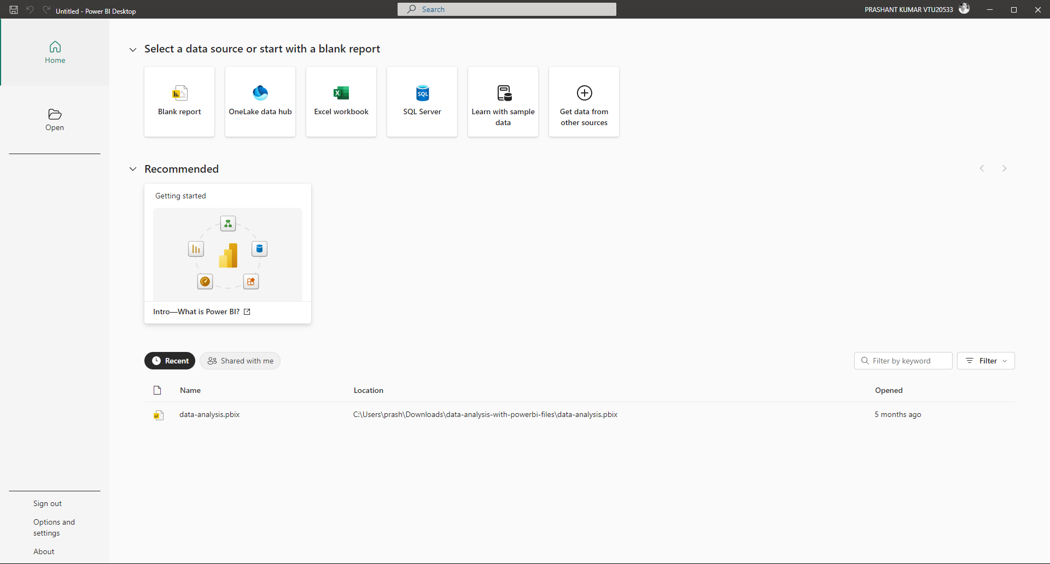

Step2> the Black window called as as canvas this canvas we make mutliple chart.

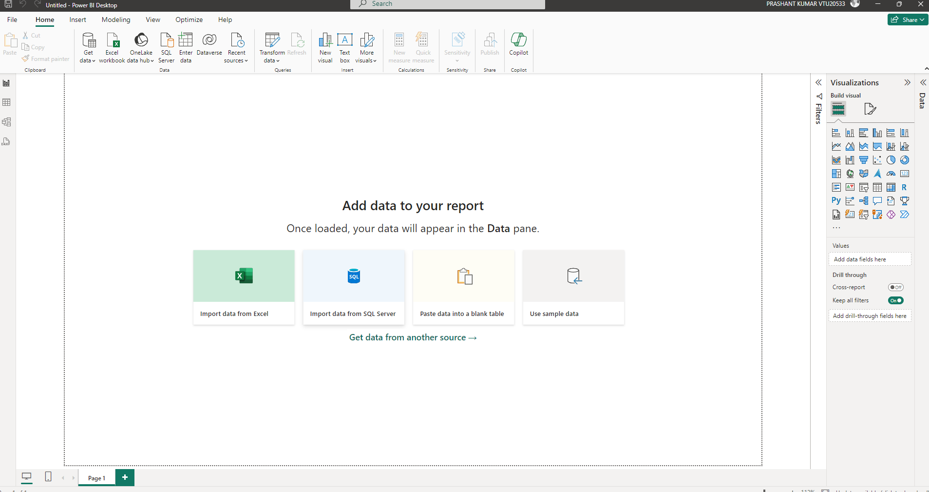

Step3> click the get data button here you can extract data from multiple sources

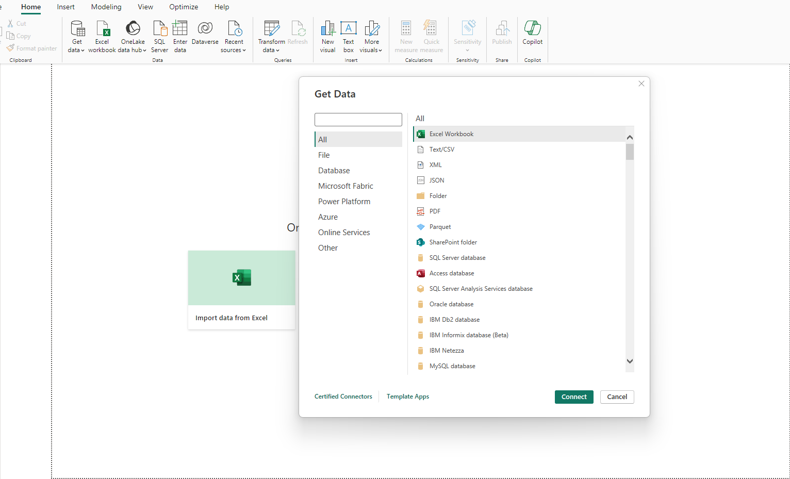

Step4> select CSV file you can get nice overview of the data .

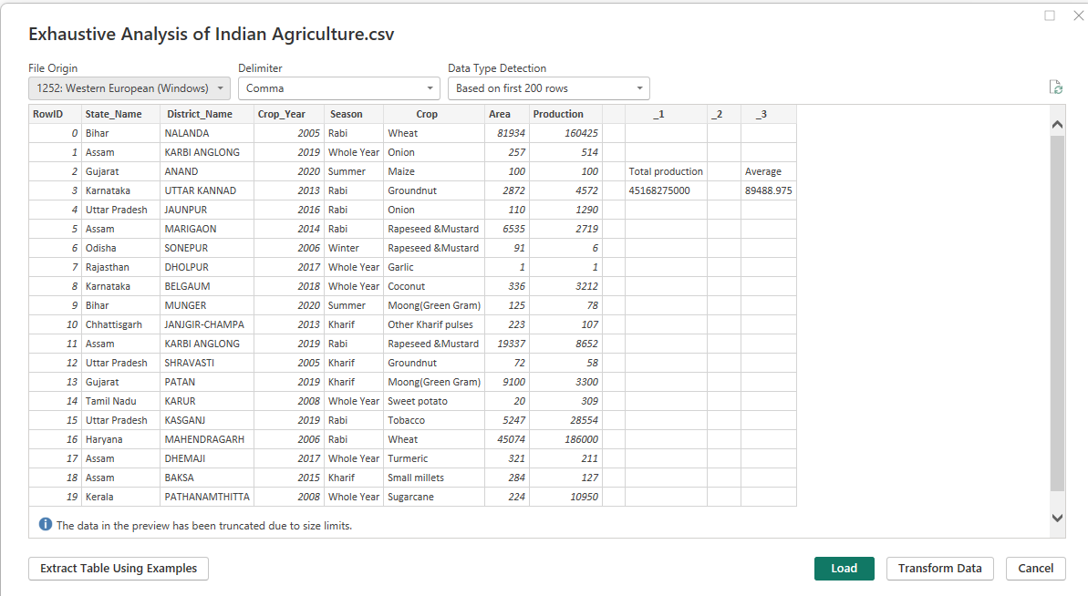

STEP 5> Click on transform button power query editoer windows are open.

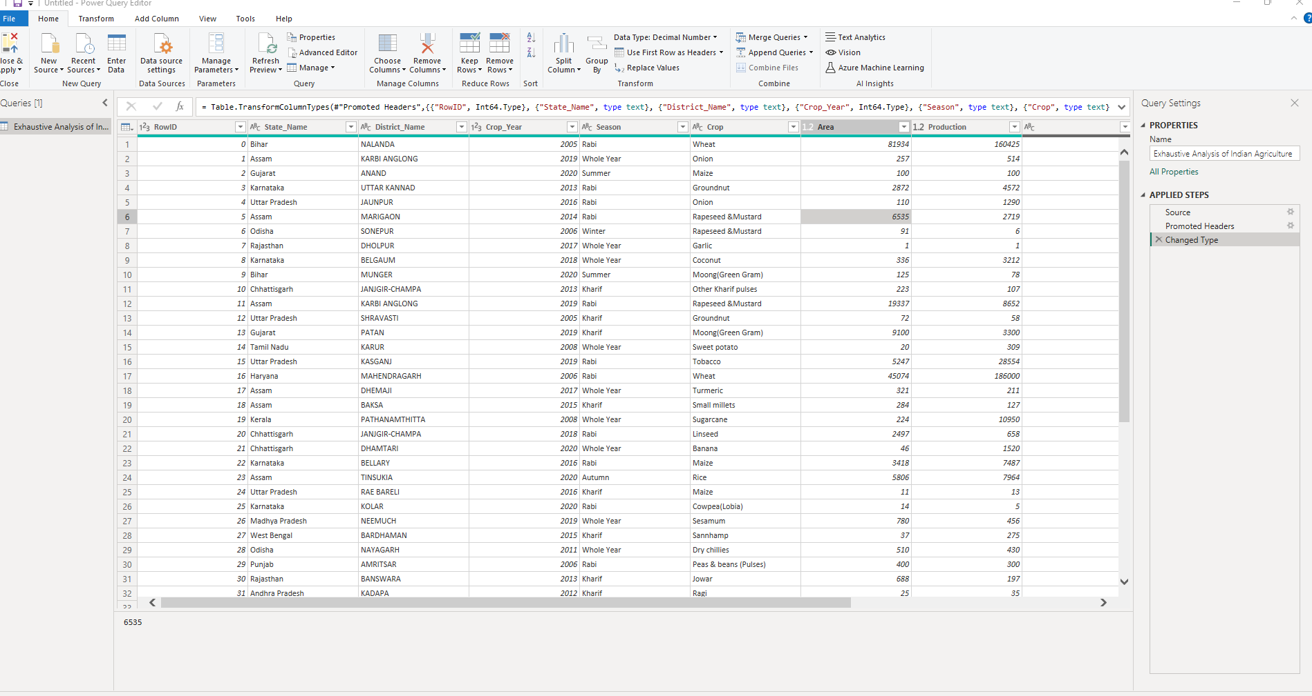

Step 6> just click particular column and click on remove button if you mistakenly did the right hand side click remove column.

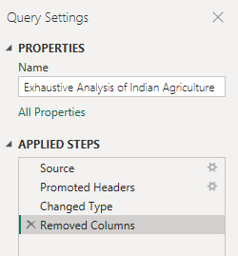

Step 7> just click on view button and click on column quality option.

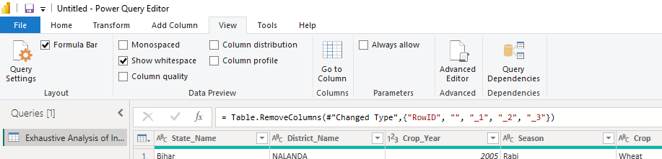

Step 8> in home button you get remove rows in that you get remove duplicate and null value.

